EC2 Tag Compliance Enforcer – Documentation

# 1. Index

1. Index  
2. Description  
3. Architecture Diagram  
4. Functionality

# 2. Description

This project enforces tagging policies for EC2 instances using AWS Lambda and EventBridge. If a newly launched EC2 instance does not have a specific tag (`XYZPQR`), it is automatically terminated. This helps organizations maintain tag compliance and avoid orphaned or misconfigured resources.

# 3. Architecture Diagram

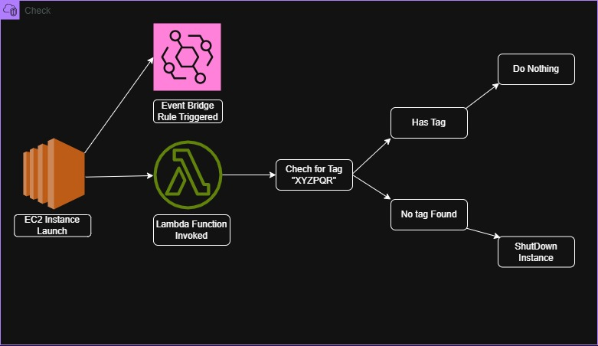

The architecture consists of the following components:

- Amazon EC2: Launches the instances

- Amazon EventBridge: Detects EC2 instance launch events

- AWS Lambda: Triggered by EventBridge to check and terminate untagged instances

- AWS IAM: Provides permissions for Lambda to describe and terminate EC2 instances

# 4. Functionality

- Detects EC2 instance launches using EventBridge and CloudTrail

- Extracts instance ID from the launch event

- Waits a few seconds to ensure tags are applied

- Uses boto3 to describe the EC2 instance

- If tag `XYZPQR` is not found, the Lambda function terminates the instance

- All actions are logged to Amazon CloudWatch for auditing